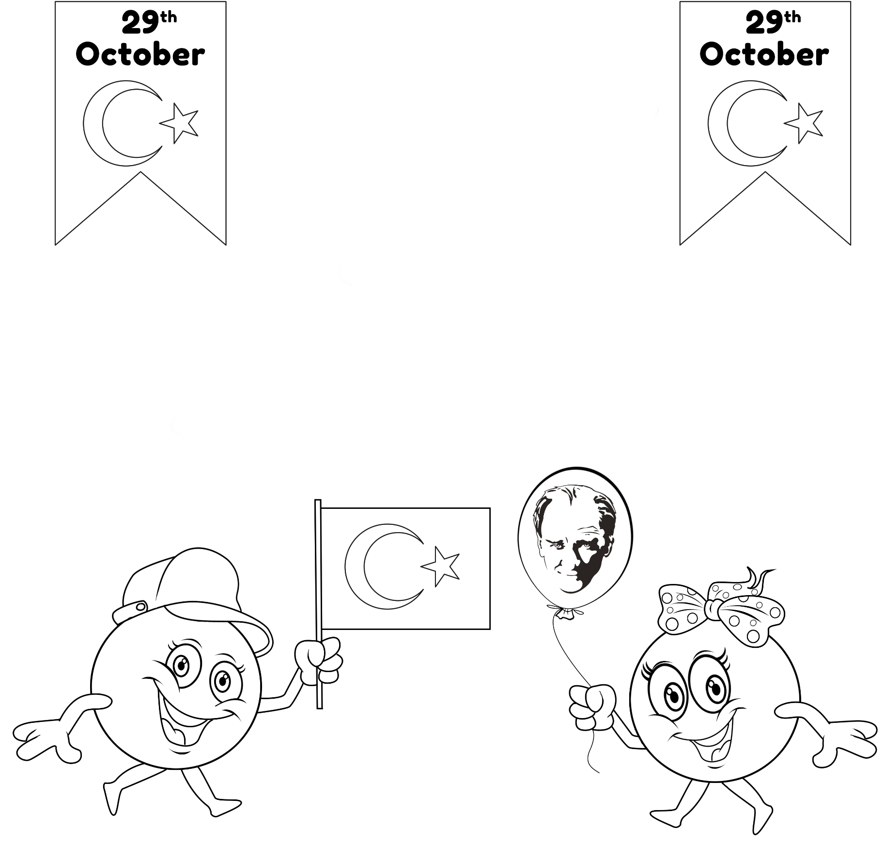

Republic Day!

Happy

ATATÜRK!

Thank you