


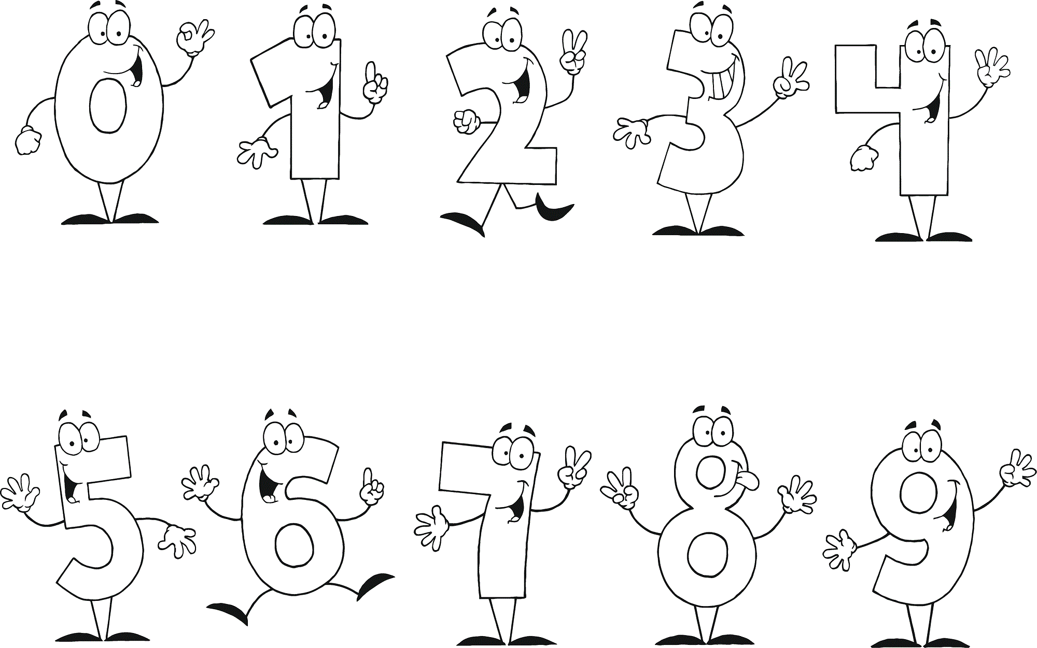

Trace A and Number
1
Trace A and Colour
Eight

Nine

Eight

Nine

Three

Five

Two

Six

Four

One

Two

Six

Ten

Seven

Four

One

Ten

Seven

Three

Five


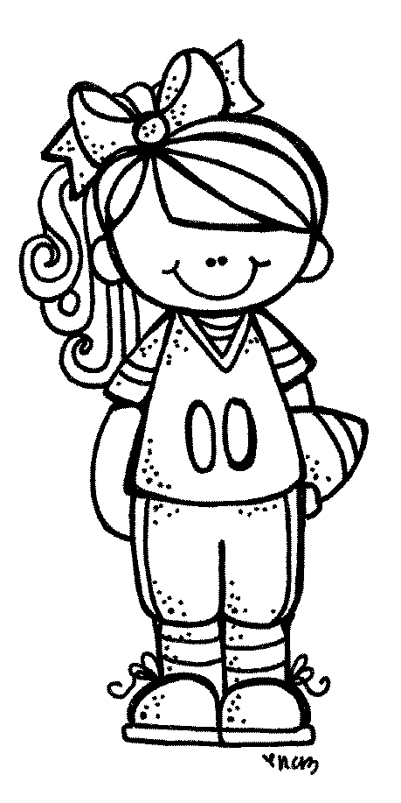
Masal
Derin
Duru

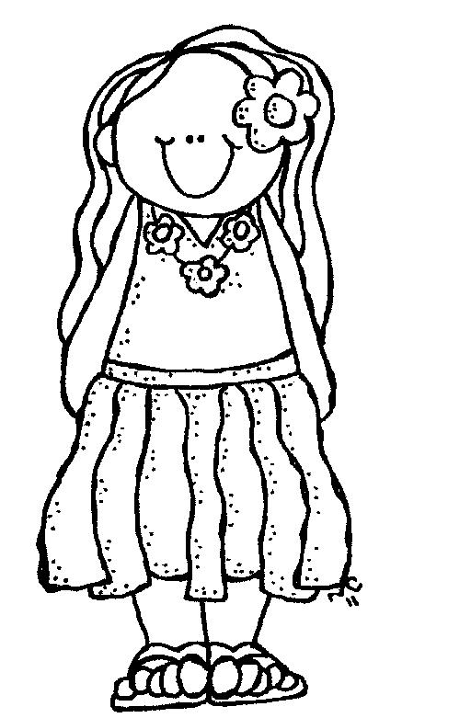

Mira
Oğuz

I am Mira.
I am seven years old.
by aogultegin
I am Duru.
I am five years old.
I am Oguz.
I am eight years old.
I am Derin.
I am ten years old.
I am Masal.
I am four years old.

