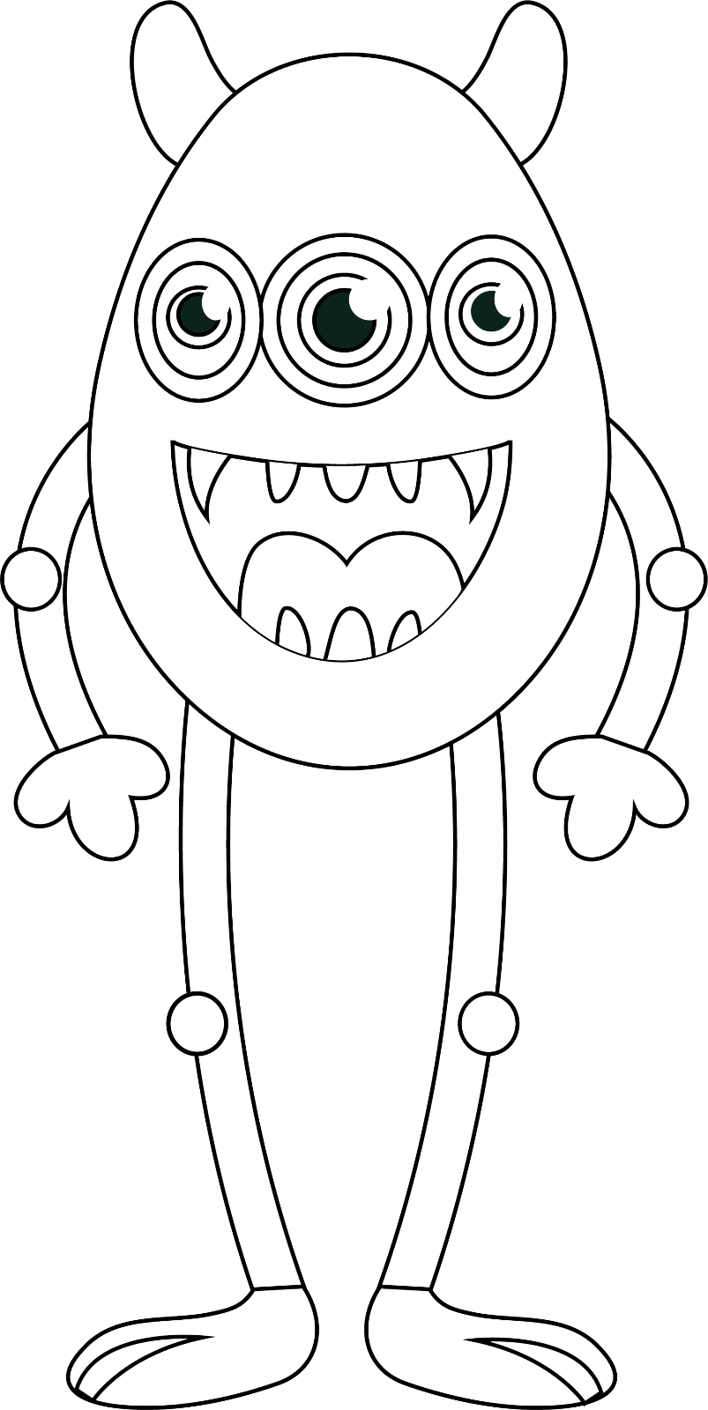
by aogultegin
1 . This is my finger. Let’s colour it pink.
2. This is my mouth. Let’s colour it purple.
3. This is my foot. Let’s colour it blue.
4. This is my leg. Let’s colour it gray.
5. This is my hair. Let’s colour it orange.
6. This is my knee. Let’s colour it yellow.
7. This is my eye. Let’s colour it green.
8. This is my arm. Let’s colour it black.
9. This is my ear. Let’s colour it red.
10. This is my hand. Let’s colour it brown.
11. This is my nose. Let’s colour it blue.
12. This is my head. Let’s colour it brown.
Let’s number and colour!

