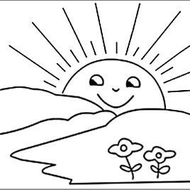


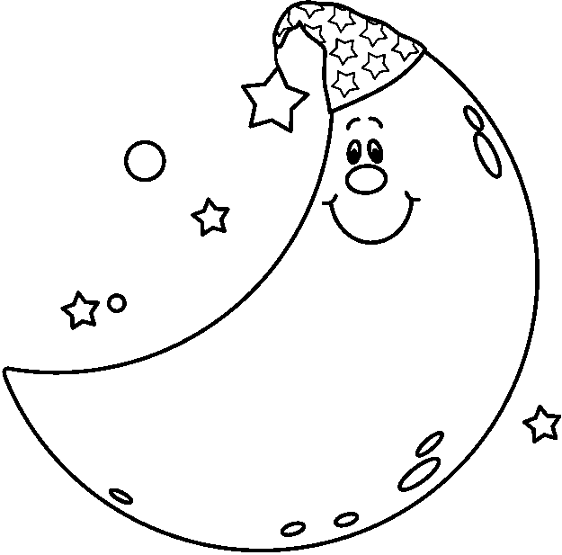
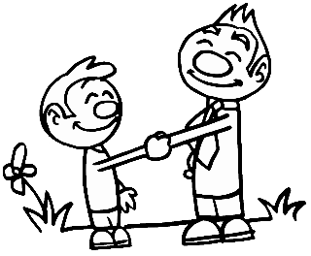
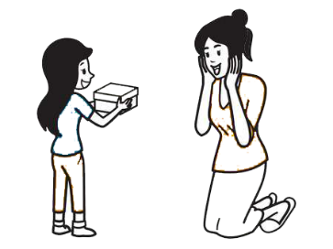
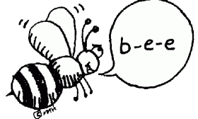
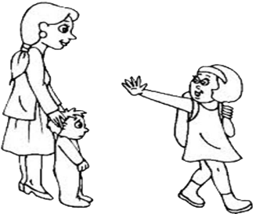
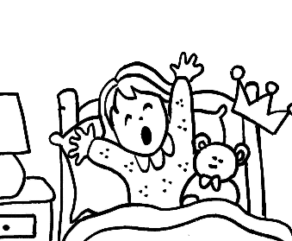
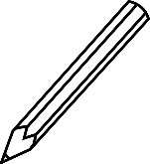

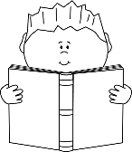
by aogultegin
Take care / Good evening / Good morning
Hi / Good afternoon / Good night /
Thanks / Spell / Nice to meet you
*Look and write .
- Spell your name, please. - I’m okay.
- See you! - I’m nine years old.
- My name is Sindy. - Hi!
- How old are you?
-
-
- A-N-D-Y.
- Hello!
-
- Goodbye!
-
- What is your name?
-
- How are you?
-
*Read and write .

