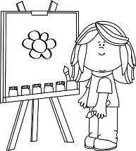
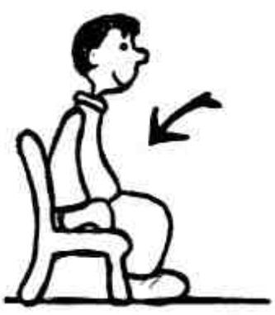
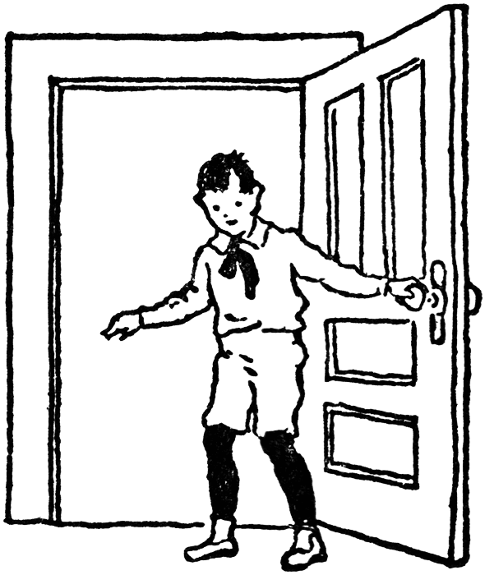
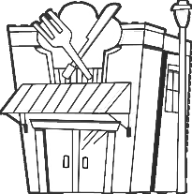

1. Sit down.
2. Cut the paper.
3. Open the door.
4. Paint the picture.
5. Close the window.
6. Draw a picture.
7. Turn left.
8. Stand up.
Number 1-2-3
1. This / That is a restaurant.
2. This / That is a laptop.
3. This / That is a biscuit.
4. This / That is a gorilla.
5. This / That is a train.
6. This / That is a hotel.
Circle

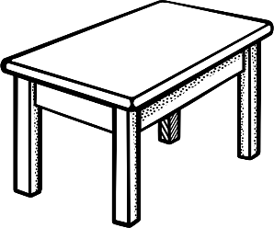
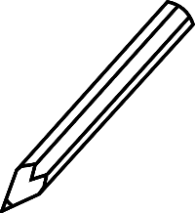
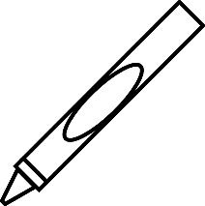
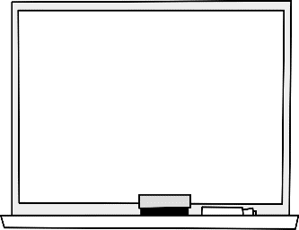
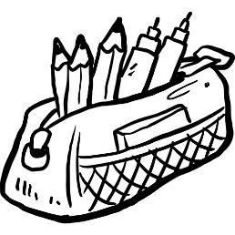
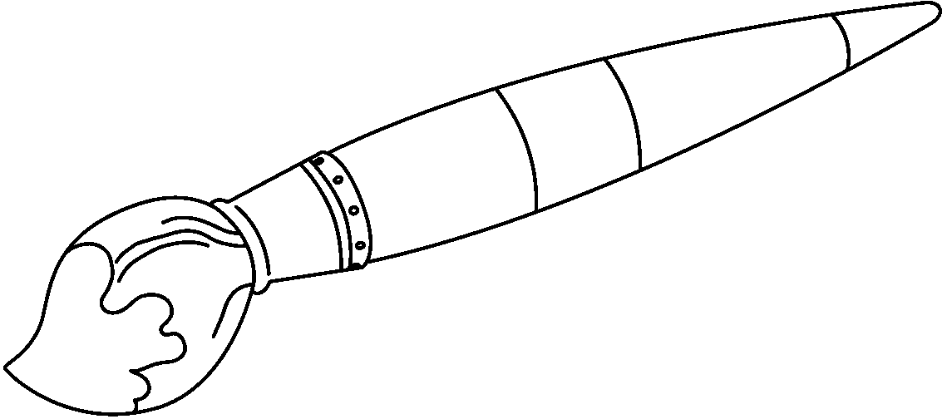
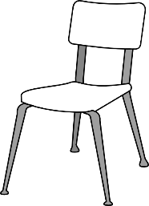
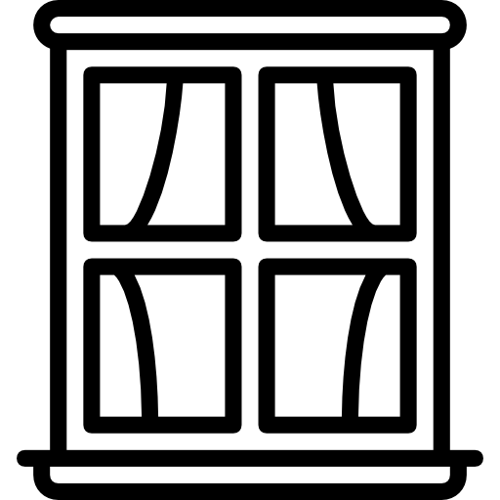
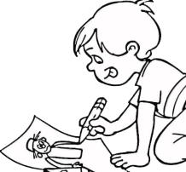
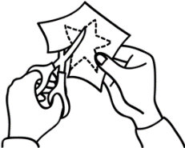
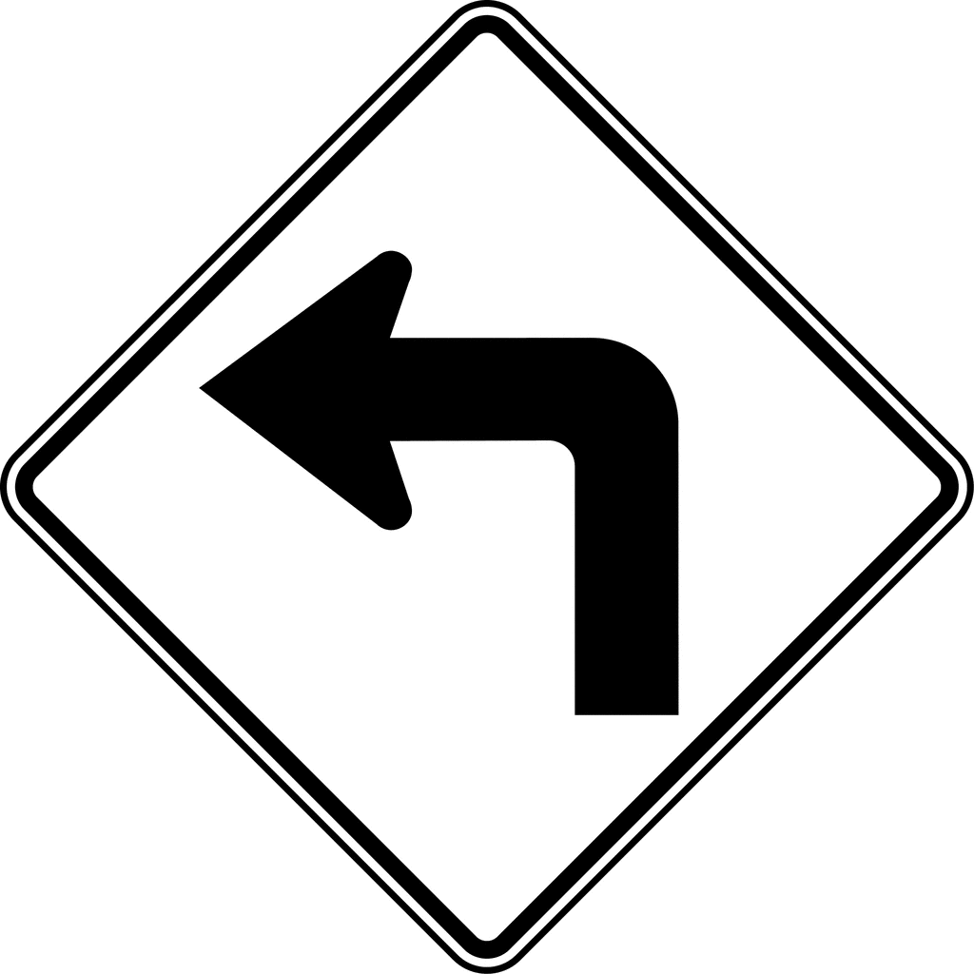
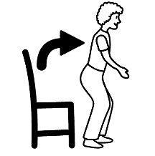

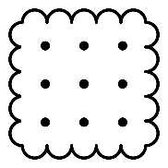
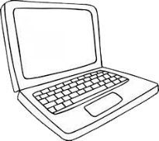

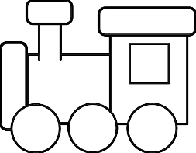
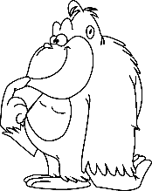
1. One table.
2. Two brushes.
3. Seven boards.
4. Five chairs.
5. Ten rulers.
6. Four crayons.
7. Nine pencils.
8. Eight pencil cases.
How many?
Hi
My
you
are
I
Goodbye
your
okay
A: ______! What is ______ name?
B: Hello! ______ name is Sindy.
A: How ______ you, Sindy?
B: I am ______. You?
A: ______ am fine. Thank ______.
B: See you!
A: __________________!
Write
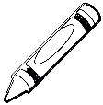
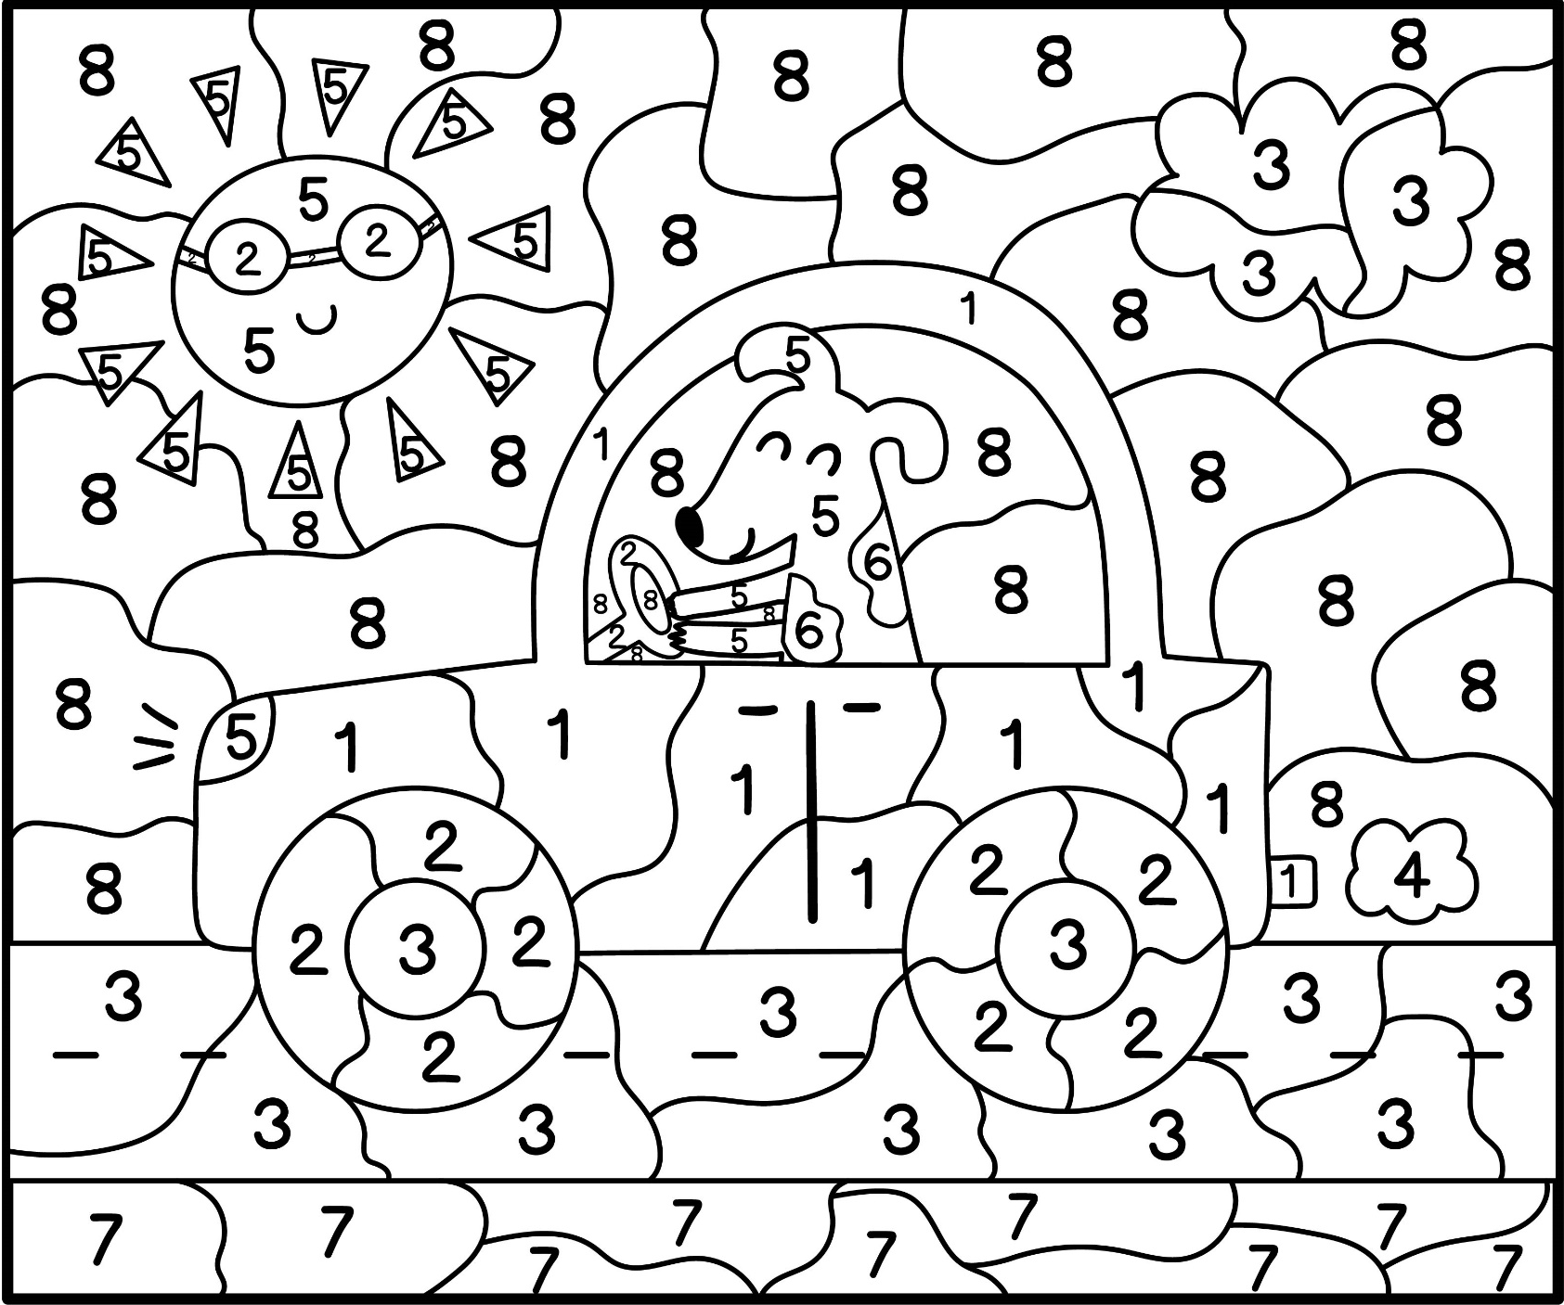
Colour
One:
Orange
Two:
Black
Three:
Grey
Four:
White
Five:
Yellow
Six:
Brown
Seven:
Green
Eight:
Blue

