  Four dogs.  Five dogs.  Three dogs.  -How many dogs? | 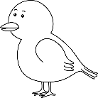  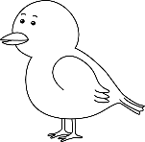  -How many birds?  Four birds.  Three birds.  Two birds.  Doğru cevabı boyayınız.
  -How many cats?  Five cats.  Six cats.  Four cats. | 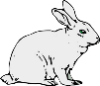  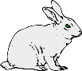  -How many rabbits?  Four rabbits.  Five rabbits.  Three rabbits.
      -How many turtles?  Five turtles.  Three turtles.  Four turtles. | 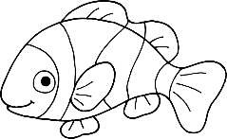  Three fish.  Two fish.  -How many fish?  One fish.

