

Circle
Write
1. She / He is my sister.
2. She / He is my daughter.
3. She / He is my uncle.
4. She / He is my son.
5. She / He is my aunt.
6. She / He is my grandmother.
7. She / He is my father.
8. She / He is my grandfather.
9. She / He is my mother.
10. She / He is my brother.

Eight – Four – Eleven – Nine – Six
Seventeen – Twenty – Fifteen – Three - Twelve
Nineteen
Thirteen
Eighteen
Fourteen
1. I a_ a st_d_n_. 9. W_at _s y_ur na_e?
2. G_od n_g_t. 10. H_l_o.
3. G__d a_te_noo_. 11. N_c_ t_ mee_ yo_.
4. Ho_ a_e __u? 12. _oo_ _or_ing.
5. H_v_ a goo_ da_. 13. H_w o_d a_e _o_?
6. S_e y_u. 14. M_ na_e i_ Mira.
7. I _m _rea_. 15. __odby_.
8. _o_d eve_in_. 16. I _m e_gh_.

Sixteen

Seven
Ten
One
Two

Five
Write

Match
1. weak
2. small
3. old
4. sad
5. fast
6. short
7. fat
8. ugly
a. big
b. strong
c. thin
d. happy
e. beautiful
f. young
g. tall
h. slow
M | I | W | S | D | C | X | H | G | W
Y | B | E | R | P | O | Z | C | N | A
C | C | I | E | Q | O | T | T | I | B
A | N | E | I | V | K | K | A | S | M
K | L | G | Y | V | A | T | W | E | A
S | P | L | A | Y | C | H | E | S | S
X | T | I | K | N | D | O | X | T | Y
O | E | U | J | H | N | M | J | W | Y
U | Y | O | D | L | F | H | P | A | L
G | T | A | A | Y | D | H | N | A | F
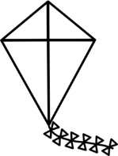
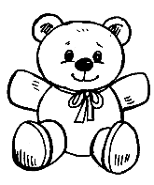
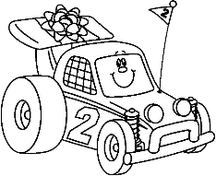
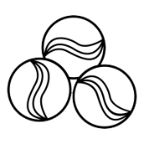
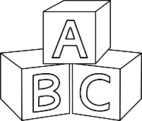
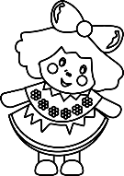
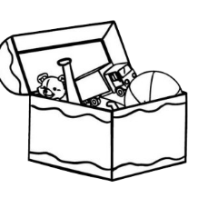

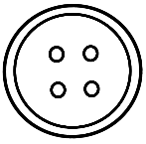
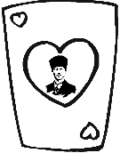
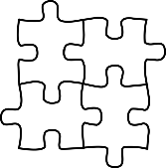
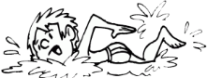
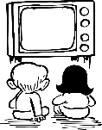


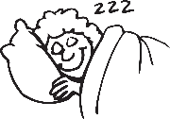
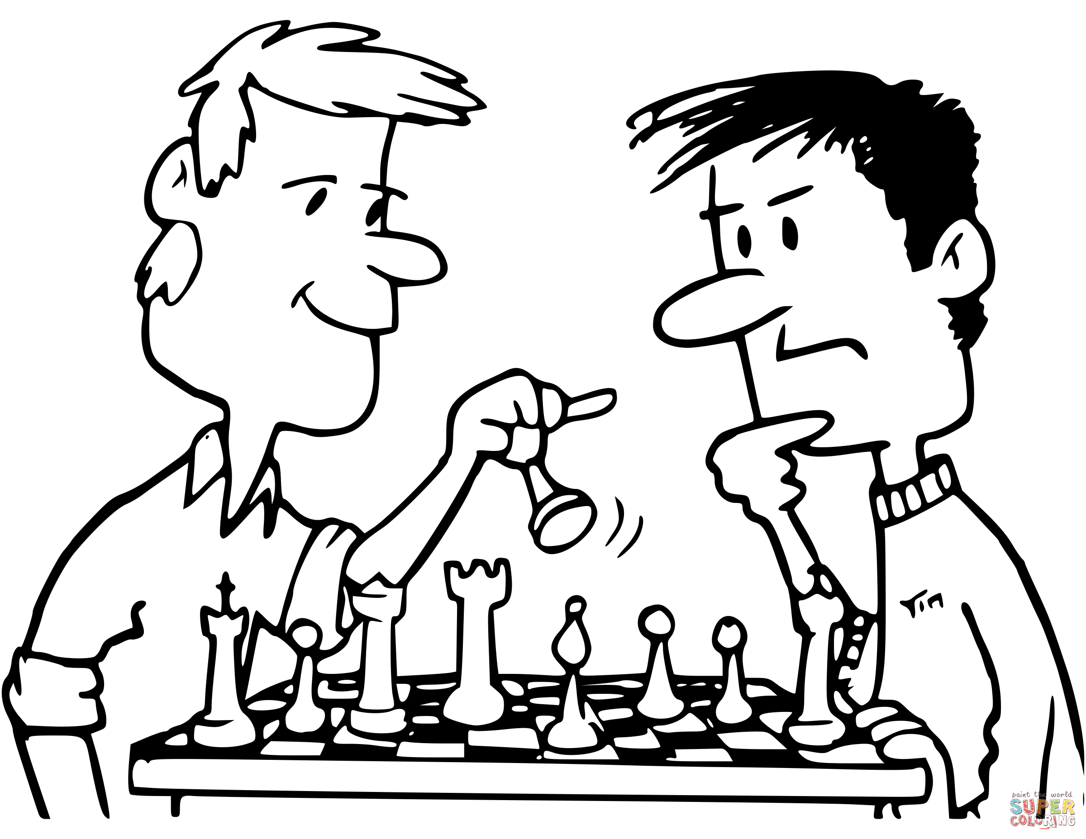
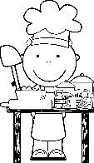
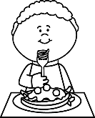


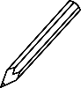
1. Colour the toy box black.
2. Colour the playing card blue.
3. Colour the toy car green.
4. Colour the marbles purple.
5. Colour the kite yellow.
6. Colour the button pink.
7. Colour the puzzles orange.
8. Colour the teddy bear red.
9. Colour the doll brown.
10. Colour the blocks grey.

Colour
Find
I am surprised.
.
I am angry.
.
.
I am hungry.
I am happy.
.
I am thirsty.
.
I am sad.
.
Draw
Circle
1. A baby can/can’t play chess.
2. A turtle can/can’t run fast.
3. A monkey can/can’t climb a tree.
4. A parrot can/can’t talk.
5. A horse can/can’t jump high.
6. A bird can/can’t fly.
7. A snake can/can’t walk.
8. A gorilla can/can’t ride a bike.
9. An elephant can/can’t sing.
10. A fish can/can’t swim.

